|  |
| --- |
| 新东方在线英语学习 |
| 新概念 1 册 |
| Lesson133-134 |



扫一扫。更多有趣的英语资讯。

# Lesson 133 单词讲解

1. reporter: 记者

report, 报告

Zhe er na la site

journalist, someone whose job is to write for

newspapers or magazines. reporter, a person who gathers news for radio,

televisions or newspapers.

Sen sei shen no

1. sensational: 爆炸性的、耸人听闻的

不同凡响的、非常棒的There is some sensational news on the newspaper. You look sensational in that dress!

Min coat

1. mink coat: 貂皮大衣

# Lesson 133 课文讲解

1. Have you just made a film? make a film: 拍电影拍照片: take a photo
2. I don’t want to …for a long time. for a long time: 长达很久，
3. By our reporter, Alan Jones… by: 由…
4. I wonder why.

wonder: want to know.

宾语从句

# Lesson 133 语法讲解

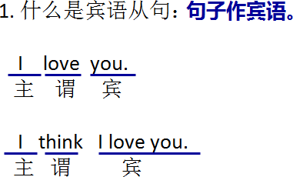 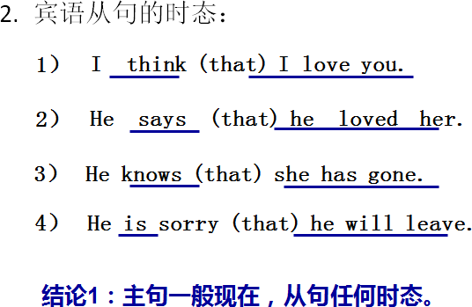

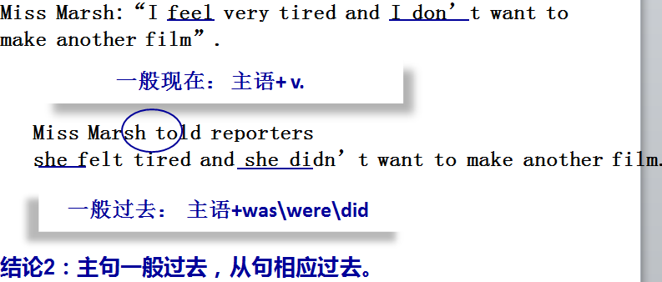

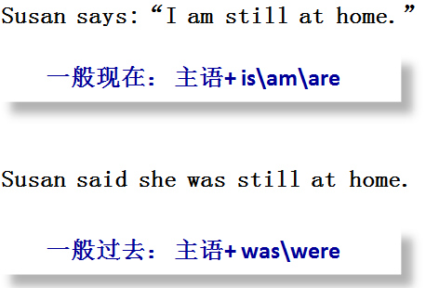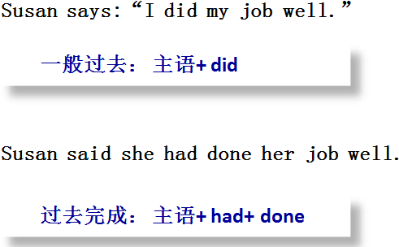

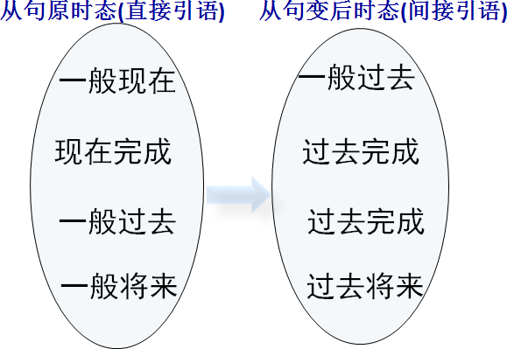

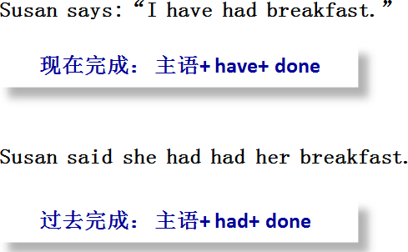

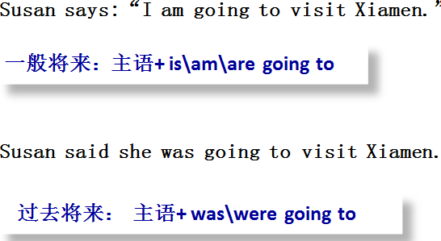

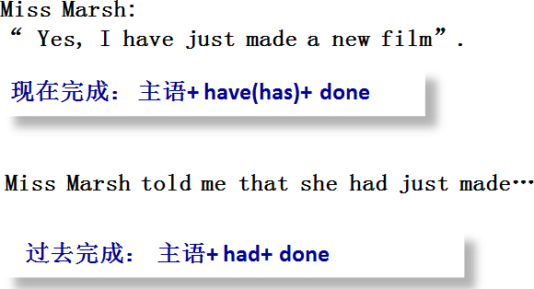

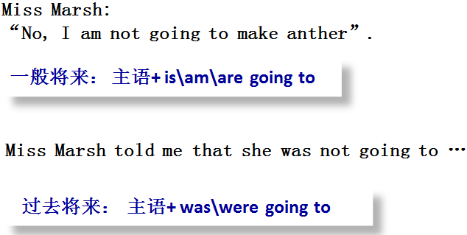

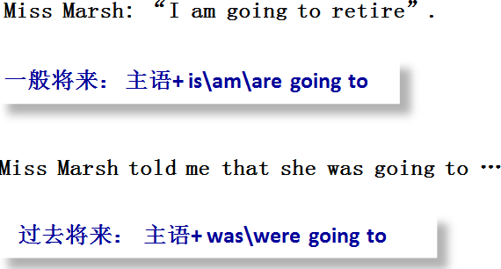

# Lesson 134 单词句型讲解

1. 模仿例句回答以下问题。
   1. I’m busy. – What did he say? He said he was busy.
   2. She’s cold.- What did he say? He said she was cold.
2. 模仿例句回答以下问题。
   1. I’m working. -What did he tell you? He told me he was working.
   2. She’s leaving. – What did they tell you? They told me she was leaving.
   3. They’re joking. – What did she tell you? She told me they were joking.
3. 模仿例句回答以下问题。
   1. I’ve met him. -What did he tell you? He told me he had met him.
   2. I’ve lost it. – What did he tell you? He told me he had lost it.
   3. It has stopped. – What did she tell you? She told me it had stopped.

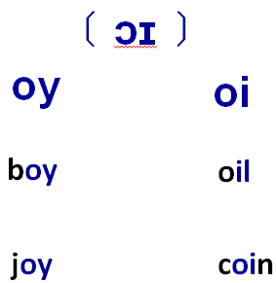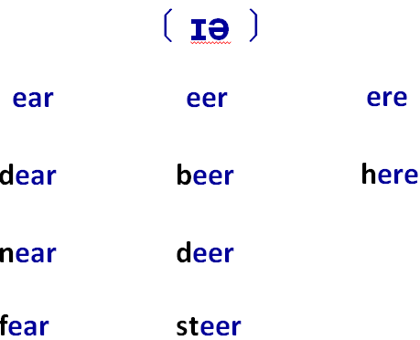

**Lesson 133&134 知识拓展**

